THEORY QUESTIONS
1.
(a)

The diagrams below are illustrations of an experiment to demonstrate a biological principle.
Study the diagrams carefully and answer the questions that follow.
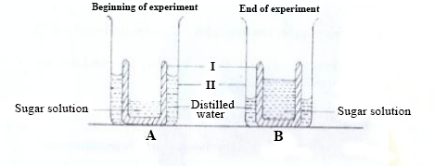
(i)

Name the parts labelled I and II.
(ii)

State two differences between the set-ups A and B.
(iii)

What is the role played by the part labelled I in the experiment?
(iv)

Name the biological principle being demonstrated in this experiment.
(v)

State one way in which plants benefits from the principle named in (iv).
(vi)

State one way in which animals benefit from the principle named in (iv).
(b)

In an experiment to investigate the reactivity of zinc, a piece of the metal was dropped into a test tube containing dilute hydrochloric acid. The experiment set-up is illustrated below.
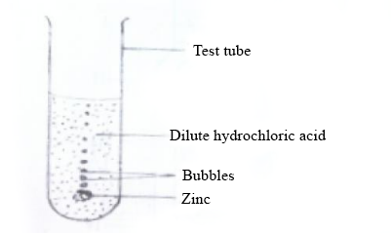
Study the set-up carefully and answer the questions that follow.
(i)

Write a balanced chemical equation for the reaction that occurred in the experiment.
(ii)

Name the gas evolved.
(iii)

List two metals which can react in a similar way as the zinc.
(iv)

List two metals which cannot react in a similar way as the zinc.
(v)

Name two glass apparatus which could have been used instead of the test tube.
(c)

The diagram below is an illustration of a thermos flask.
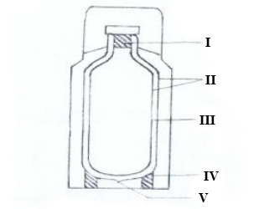
Study the diagram carefully and answer the questions that follow.
(i)

Name the parts labelled I, II, III, IV and V.
(ii)

How does the device minimize heat loss or gain through
(α)

conduction?
(β)

convection?
(γ)

radiation?
(iii)

State one use of the thermos flask.
(d)

The diagrams below illustrate an experimental set-up on a physical property of soil using three soil types X, Y and Z.
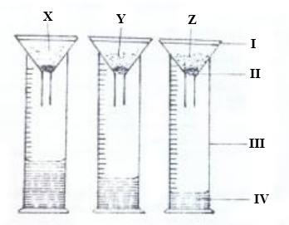
Study the set-up carefully and answer the questions that follow:
(i)

Name the parts of the set-up labelled I, II, III and IV.
(ii)

Which of the three soil types has the
(α)

highest water holding capacity?
(β)

least water holding capacity?
(iii)

Name each of the three soil types X, Y and Z.
(iv)

Suggest a suitable title for the experiment.

2.
(a)

List the three particles which make up matter.
(b)

State four hereditary features in humans.
(c)

State the energy transformation that takes place in each of the following activities:
(i)

dry cell in use;
(ii)

solar panel in use;
(iii)

electric stove in use;
(iv)

hammering of a piece of metal.
(d)

State two ways each in which each of the following cultural practices is important in vegetable production:
(i)

staking;
(ii)

pruning.

3.
(a)

(i)

What is indiscriminate sex?
(ii)

Give two reasons why teenagers indulge in indiscriminate sex.
(b)

Name two sources each of
(i)

natural light;
(ii)

artificial light.
(c)

State three ways in which soil texture is important in crop production.
(d)

Write down the systematic name of each of the following chemical compounds:
(i)

FeS;
(ii)

CO;
(iii)

Cu₂O;
(iv)

NaOH.

4.
(a)

(i)

What do the symbols L, N and E represent in an electric plug?
(ii)

What is the function of the fuse box in household electrical wiring?
(b)

Mention four classes of insect pest based on their feeding habits.
(c)

Classify the first four elements of the periodic table as metals and non- metals.
(d)

Name the three types of blood vessels in humans.

5.
a)

i)

State the difference between organic fertilizer and inorganic fertilizer.
ii)

State two effects of inorganic fertilizer on the environment.
b)

Classify the following substances as acids or bases.
i)

unripe lemon juice;
ii)

wood ash;
iii)

liquid in a car battery;
iv)

bicarbonate of soda.
c)

i)

What is a fruit?
ii)

State two differences between a fruit and a seed.
d)

State the effect of heat on each of the following substances:
i)

plastics;
ii)

alcohol;
iii)

metal rod.

6.
a)

Classify the following chemical substances basd on their uses under the headings as shown in the table below: Milk of magnesia, alcohol, paracetamol, sodium hydroxide, N.P.K.
Agricultural | Industry | Medicine
b)

State one use each of the following instruments used in the study of the weather:
i)

rain gauge;
ii)

hygrometer;
iii)

anemomoter.
c)

i)

Name two types of transistors.
ii)

Draw and label the circuit symbols of the transistors named in (i).
d)

State three reasons why vegetable farming is important.

